**Task 1**

Creating Database **Task**



Create table Department and Employee according to Question

**For Department**



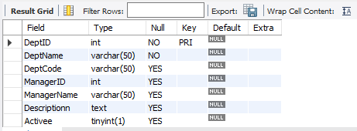

Inserting Values

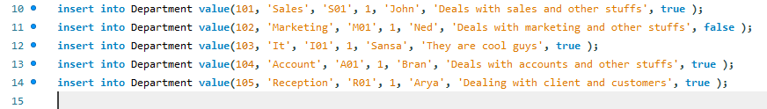

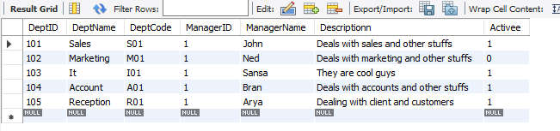

**For Employee**

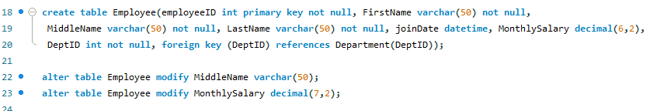

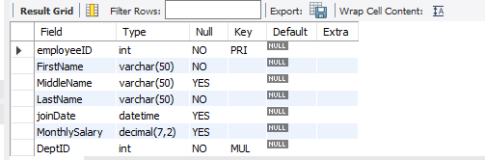

Inserting Values

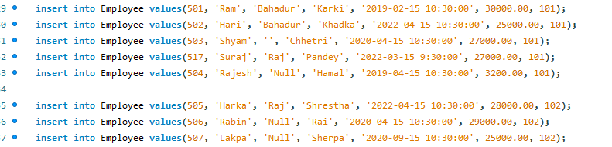

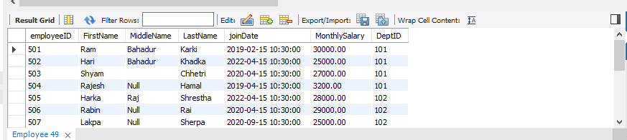

**Query Question**

1. Write a Single Query to find the Total Earnings by Employees grouped by Departments.

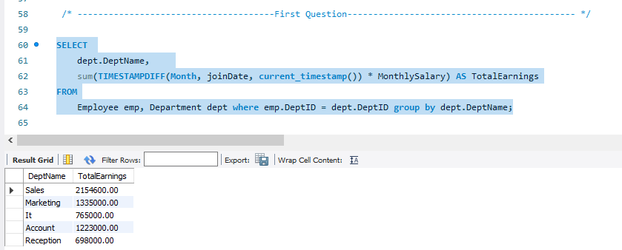

1. Write a Single Query to find the list of Employees belonging to Department Sales, with service length of more than 6 months.

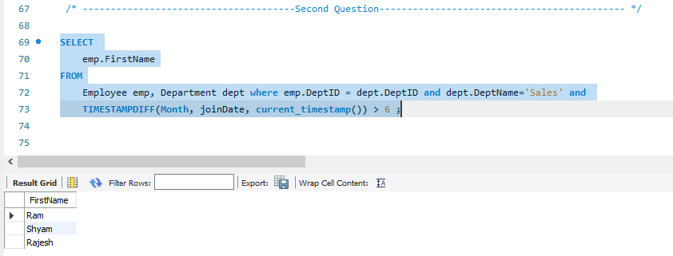

1. Write a Single Query to list Employees with their Department Name and their Manager Name.

